Scenario in Text

No.2 Search events in the calendar

Photo:

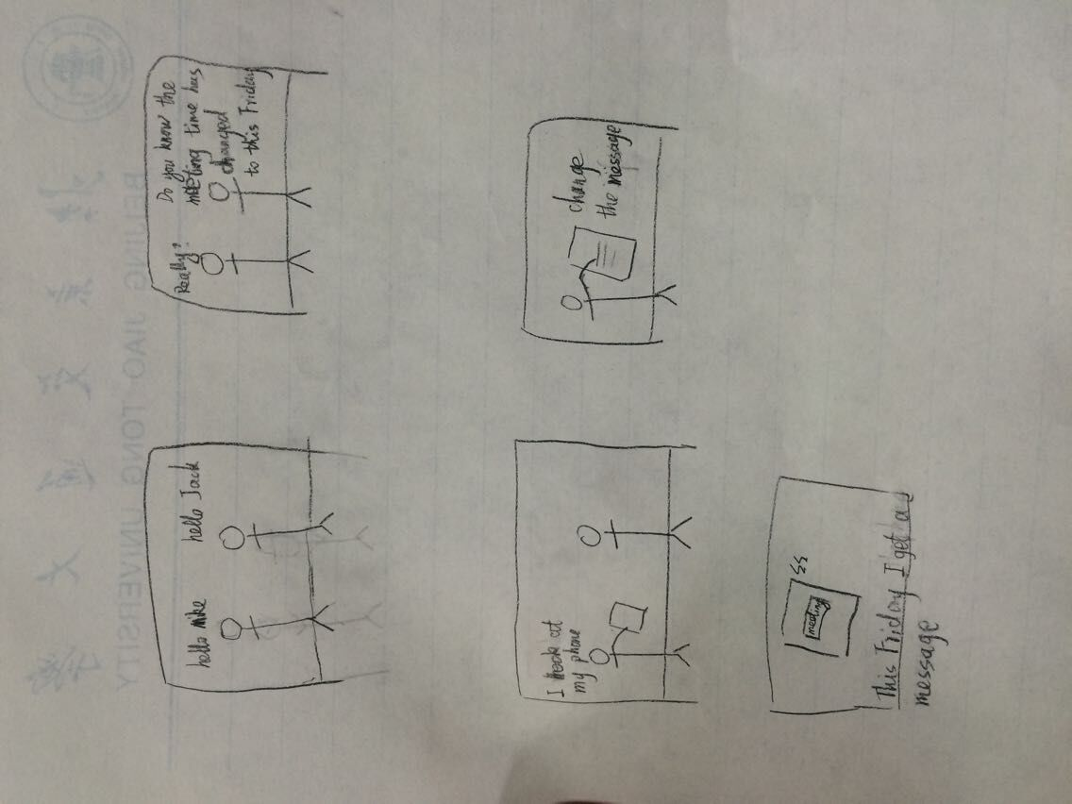

Before:

I have written some message in the app,but I forget when to do it.And I want to find it and do some changes(update or delete).

During:

So that I open the app and chose the “search” button .And I find the message,I do some changes.

After:

When the day come, the phone will remind me . So, I will never forget that thing.

Use Case4—Find all Notes

Precondition-The user add an event

Description-The user presses the “Search” button. The list appears and show all the message.

Post-condition-The user can select/update/delete a message.

Exception-The user didn’t add any message and the system will give promote message.

Use Case5—Select one Note

Precondition-The user add an event and find all notes

Description-The user open the app and presses the “Search” button. The list appears and show all the message and the user input the key words.

Post-condition-The user can update/delete a message.

Exception-The user didn’t find anything through the key words and the system will give promote message.

Use Case6—Update a Note

Precondition-The user select an event

Description-The user press “update”/”delete” button. “update”:it will turn to the add page with the old message,the user can update it.”delete”:the message will delete with the permission of the user.

Post-condition-The user can find a new message.

Exception-The user didn’t want to change the message .It will have no change without permission.